Open Mind <openmindcbb@gmail.com>
Feb 21, 2014, 10:55 AM
I am so glad it worked out for Aishwarya! Please keep us posted on how everything is going and let us know if there's ever anything we might be able to do to help your kiddos. You can read the story here: http://streamofconsciousness1234.wordpress.com/2014/02/20/it-takes-a-world-to-change-the-world/
Warmly,
Marina
Marina Vaserman
Open Mind Director
www.openmindschool.org
www.openmindcenter.org
818.426.1066

www.openmindcenter.org
818.426.1066

During this trip I was fortunate to be afforded the opportunity to meet other families and schools trying to help the special needs community. Among the different centers where we volunteered, there was a home based school run by a mother of a child with multiple disabilities. This was the start of what promises to be a beautiful lifelong friendship.
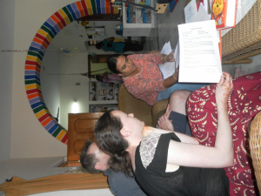
A couple weeks ago I received an email that a 6 year old in India is in desperate need of a wheelchair. This incredible picture made it’s way to my inbox.
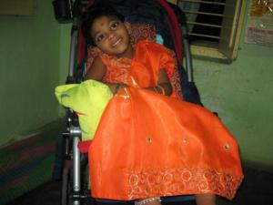
Without hesitation the family in LA offered to donate the wheelchair their son (who is now walking independently) does not use anymore. Thanks to social media a couple friends were compelled and kind enough to reach out to their contacts. A high school friend’s mom shared the story with the owners of Disability Dealer Magazine, a resource for buying and selling wheelchair accessible vehicles and medical equipment. The married couple planned a trip to Northern CA. The wheelchair was driven to their son’s physical therapy office SCORE in Soquel CA.
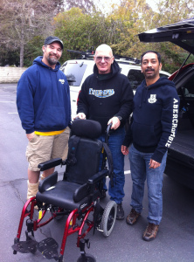
A family from Foster City picked up the chair and got ready for the journey ahead. The wheelchair traveled 8,425 miles this week. Here’s the e-mail I received from mom this morning:
Hi Marina,
I have received the wheelchair today morning. I am happy to say that Aishu looks very comfortable and safe in it.
Thank you so much, I really dont have words for expressing my thanks towards you and the family who donated the wheelchair for Aishu. I would have never been able to buy such a good one for my daughter. Once again thank you. Plz convey my regards to the family who donated the chair.
Warm wishes,
Archana
I received this from the director of the home school program this evening:
Hi Marina,
We received the wheel chair for the little girl, Aishwarya. Parents are so excited. I want to thank you and the family who donated the chair personally but is not possible. Please convey my wishes and blessings for the family. I heard you had to go through lot to make it happen. My hearty thanks to you and God bless you and your family.
Regards,
Himabindu,
www.abhilashakids.org
Look at this happy girl…in her new wheelchair!
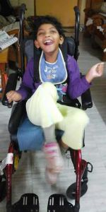
It took many organization, professionals, and warm hearted families to make this happen for Aishu. But more than that it takes courage to be vulnerable, strength to reach out and ask for help. I am simply excited to be a small part of the puzzle. I cannot wait to make my way back to India and hope to meet this beautiful girl whose smile brightened my life this month.

